Assignment 1 for Spatial Programming

Jan 24, 2015

Xiaohu Liu

**Chapter 4**

**Exercise 1**

*Move the last line of this program to the top, so the function call appears before the definitions. Run the program and see what error message you get.*

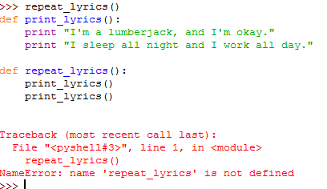

**Exercise 2**

*Move the function call back to the bottom and move the definition of print_lyrics after the definition of repeat_lyrics. What happens when you run this program?*

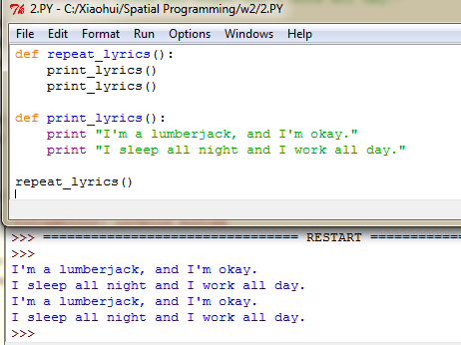

This program works well because the *repeat_lyrics* was called after *print_lyrics* was defined. The flow of execution is not the same as sequence of appearance in the program.

**Exercise 3**  

*Python provides a built-in function called len that returns the length of a string, so the value of len('allen') is 5.*

*Write a function named right_justify that takes a string named s as a parameter and prints the string with enough leading spaces so that the last letter of the string is in column 70 of the display.*

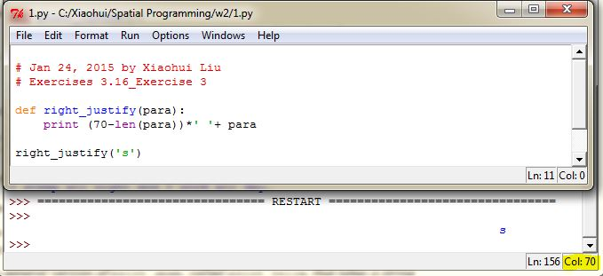

**Exercise 4**

1. *Type this example into a script and test it.*
2. *Modify do_twice so that it takes two arguments, a function object and a value, and calls the function twice, passing the value as an argument.*
3. *Write a more general version of print_spam, called print_twice, that takes a string as a parameter and prints it twice.*
4. *Use the modified version of do_twice to call print_twice twice, passing 'spam' as an argument.*
5. *Define a new function called do_four that takes a function object and a value and calls the function four times, passing the value as a parameter. There should be only two statements in the body of this function, not four.*

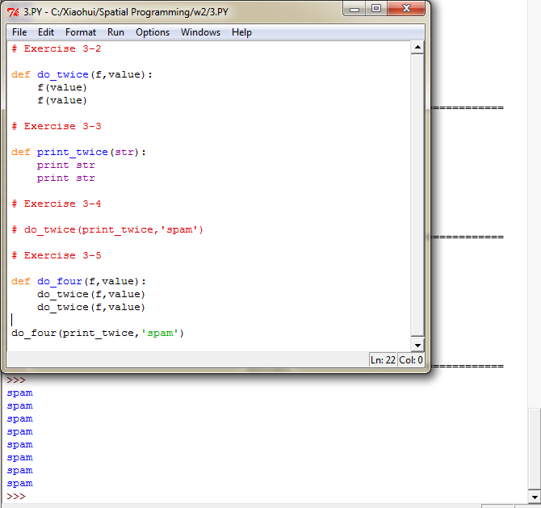

**Exercise 5**

1 2*2 grid:

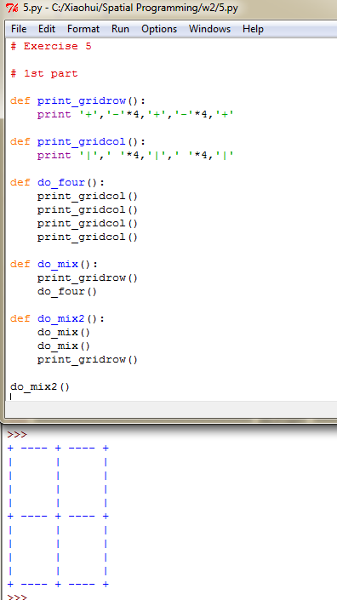

2. 4 by 4 grid:

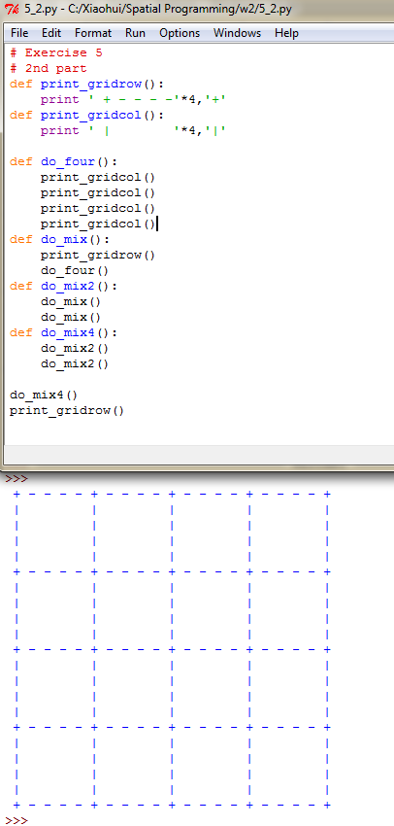

**Chapter 5 Conditions and Recursion**

1. **Draw a stack diagram for *print_n.***

s🡪’Hello’,n=2

s🡪’Hello’,n=1

print_n

print_n

<module>

1. **Write a function called *do_n* that takes a function object and a number, *n*, as arguments, and that calls the given** function *n* times.

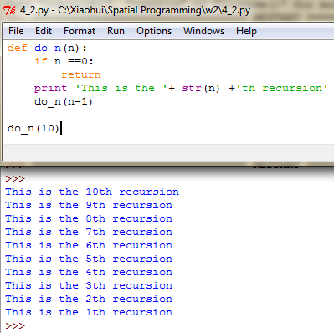

1. **Fermat’s Last Theorem**

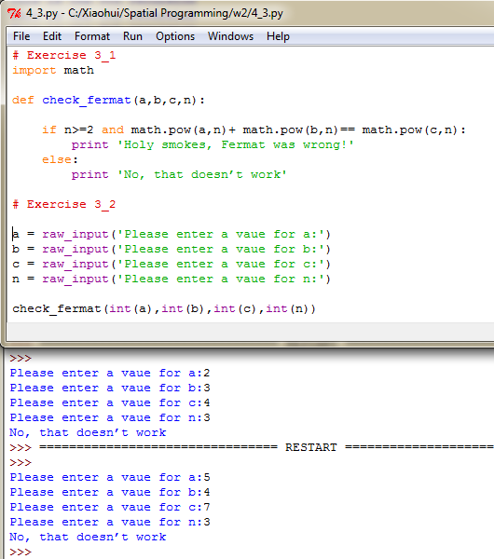

1. **Testify the possibility to form a triangle.**

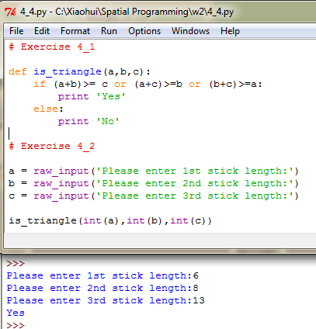

**Chapter 6 Fruitful Functions**

**Ex 1 Write a *compare* function that returns *1* if *x > y*, *0* if *x == y*, and *-1* if *x < y*.**

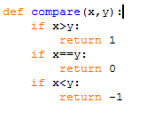

**Ex2 a function called *hypotenuse***

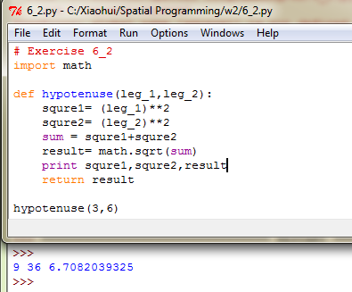

**Ex 3 Write a function *is_between(x, y, z)* that returns *True* if x ≤ y ≤ z or *False* otherwise.**

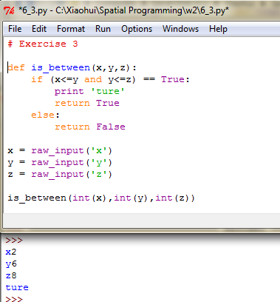

**EX4 Draw a stack diagram for the following program. What does the program print?**

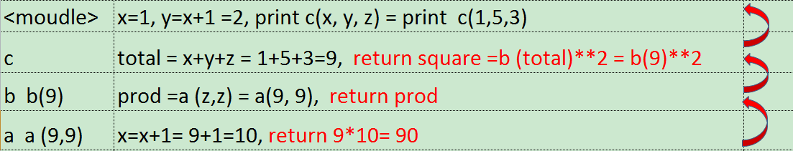

It prints 9,10 and 8100

**Ex 5 Write a function named *ack* that evaluates Ackermann’s function.**

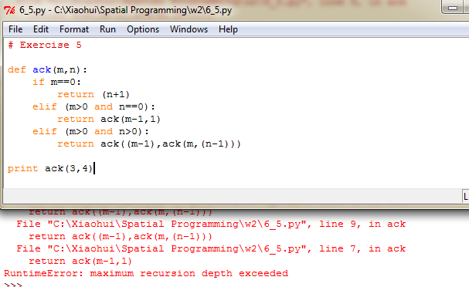

If large values of m and n (eg. 100 & 50) are passed to the function, a RuntimeError will show up, indicating that maximum recursion depth exceeded.

**Ex 6 The following are functions that take a string argument and return the first, last, and middle letters:**

1. If the middle function is called with one, two, or zero letter as parameter, nothing will be returned.
2. Write a function called *is_palindrome* that takes a string argument and returns *True* if it is a palindrome and *False* otherwise. Remember that you can use the built-in function *len* to check the length of a string.

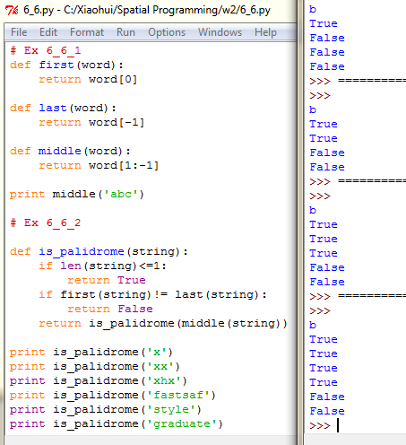

**Exer 7 A number, a, is a power of b if it is divisible by b and a/b is a power of b. Write a function called *is_power* that takes parameters *a* and *b* and returns *True* if *a* is a power of *b*. Note: you will have to think about the base case.**

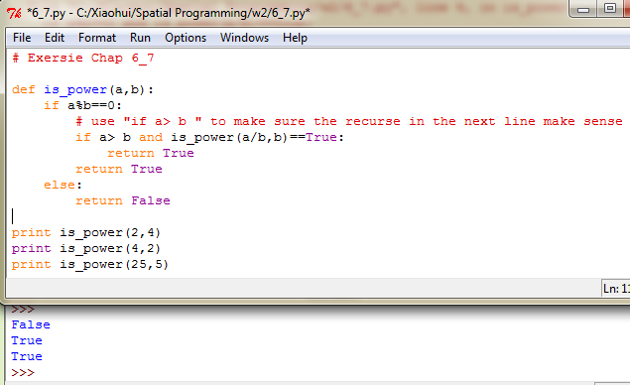

**Exe 8 Write a function called *gcd* that takes parameters *a* and *b* and returns their greatest common divisor.**

